Звіт з бд

лр 3(3,4)

Гніздовський Максим

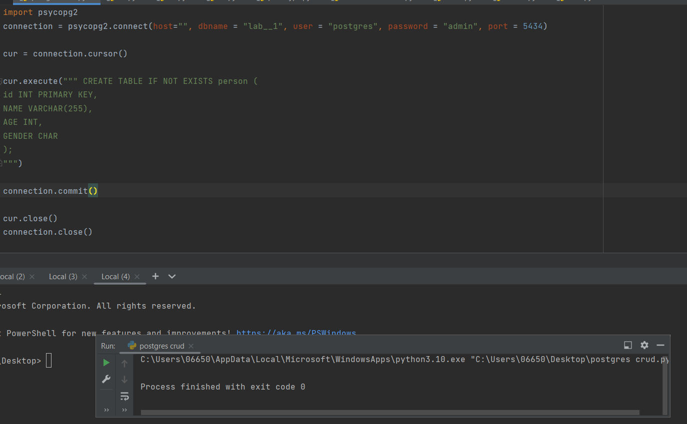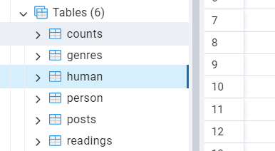

Процедури, тригери, транзакції, індекси

CREATE OR REPLACE FUNCTION create_reader(

username varchar,

date_of_birth timestamp,

role varchar

)

RETURNS integer

AS $$

BEGIN

INSERT INTO readers (username, date_of_birth, role)

VALUES ($1, $2, $3);

RETURN LASTVAL();

END;

$$ LANGUAGE plpgsql;

CREATE OR REPLACE FUNCTION create_post(

title varchar,

body text,

genres_id integer

)

RETURNS integer

AS $$

BEGIN

INSERT INTO posts (title, body, genres_id)

VALUES ($1, $2, $3);

RETURN LASTVAL();

END;

$$ LANGUAGE plpgsql;

CREATE OR REPLACE FUNCTION mark_post_as_read(

reader_id integer,

post_id integer

)

AS $$

BEGIN

INSERT INTO post_readings (reader_id, post_id)

VALUES ($1, $2);

END;

$$ LANGUAGE plpgsql;

CREATE OR REPLACE TRIGGER trigger_update_reader_last_login_on_login

BEFORE UPDATE ON readers

FOR EACH ROW

WHEN NEW.username = OLD.username

AS $$

BEGIN

UPDATE readers

SET last_login = CURRENT_TIMESTAMP

WHERE id = NEW.id;

END;

$$ LANGUAGE plpgsql;

CREATE OR REPLACE TRIGGER trigger_increment_post_views_on_post_view

AFTER UPDATE ON posts

FOR EACH ROW

WHEN NEW.title <> OLD.title

AS $$

BEGIN

UPDATE posts

SET views = views + 1

WHERE id = NEW.id;

END;

$$ LANGUAGE plpgsql;

CREATE OR REPLACE TRIGGER trigger_send_notification_on_new_post

AFTER INSERT ON posts

FOR EACH ROW

AS $$

BEGIN

-- Send notifications to subscribers of the post's genre

-- (Implementation details depend on the notification system)

END;

$$ LANGUAGE plpgsql;

CREATE INDEX index_readers_on_username ON readers (username);

CREATE OR REPLACE TRIGGER trigger_update_reader_avg_rating

AFTER UPDATE ON post_ratings

FOR EACH ROW

WHEN NEW.reader_id = OLD.reader_id

AS $$

BEGIN

UPDATE readers

SET avg_rating = (

SELECT AVG(rating)

FROM post_ratings

WHERE reader_id = NEW.reader_id

)

WHERE id = NEW.reader_id;

END;

$$ LANGUAGE plpgsql;

CREATE OR REPLACE TRIGGER trigger_log_post_update

AFTER UPDATE ON posts

FOR EACH ROW

AS $$

BEGIN

INSERT INTO post_history (post_id, old_title, old_body, new_title, new_body, updated_at)

VALUES (OLD.id, OLD.title, OLD.body, NEW.title, NEW.body, CURRENT_TIMESTAMP);

END;

$$ LANGUAGE plpgsql;

CREATE OR REPLACE TRIGGER trigger_enforce_unique_post_titles

BEFORE INSERT OR UPDATE ON posts

FOR EACH ROW

WHEN (NEW.title = OLD.title OR EXISTS (SELECT 1 FROM posts WHERE title = NEW.title))

AS $$

BEGIN

RAISE EXCEPTION 'Duplicate post title. Please choose a unique title.';

END;

$$ LANGUAGE plpgsql;

CREATE INDEX index_posts_on_title ON posts (title);

CREATE INDEX index_genres_on_name ON genres (name);

CREATE INDEX idx_title ON posts(title);

CREATE INDEX idx_human_id ON posts(human_id);

CREATE INDEX idx_genres_id ON posts(genres_id);

explain select * from posts where

ALTER TABLE posts ADD COLUMN updated_at TIMESTAMP DEFAULT CURRENT_TIMESTAMP;

CREATE OR REPLACE FUNCTION update_timestamp() RETURNS TRIGGER AS $$

BEGIN

NEW.updated_at = NOW();

RETURN NEW;

END;

$$ LANGUAGE plpgsql;

CREATE TRIGGER update_posts_timestamp

BEFORE UPDATE ON posts

FOR EACH ROW

EXECUTE FUNCTION update_timestamp();

BEGIN;

INSERT INTO posts (id, title, bodyd, human_id, genres_id)

VALUES (7, 'New Title', 'New body content', 5, 6);

COMMIT;

BEGIN;

UPDATE posts

SET title = 'Updated Title', bodyd = 'Updated body posts'

WHERE id = 1;

COMMIT;

BEGIN;

DELETE FROM posts

WHERE id = 2;

COMMIT;

CREATE OR REPLACE FUNCTION count_contents() RETURNS INTEGER AS $$

DECLARE

posts_count INTEGER;

BEGIN

SELECT COUNT(*) INTO content_count FROM posts;

RETURN posts_count;

END;

$$ LANGUAGE plpgsql;